Autonomous Vehicle Industry Strategy & Analysis

An In-depth Look at Autonomous Vehicle Consumer & Industry Report

Ronak Shah

2025-11-27

Table of contents

# Preface

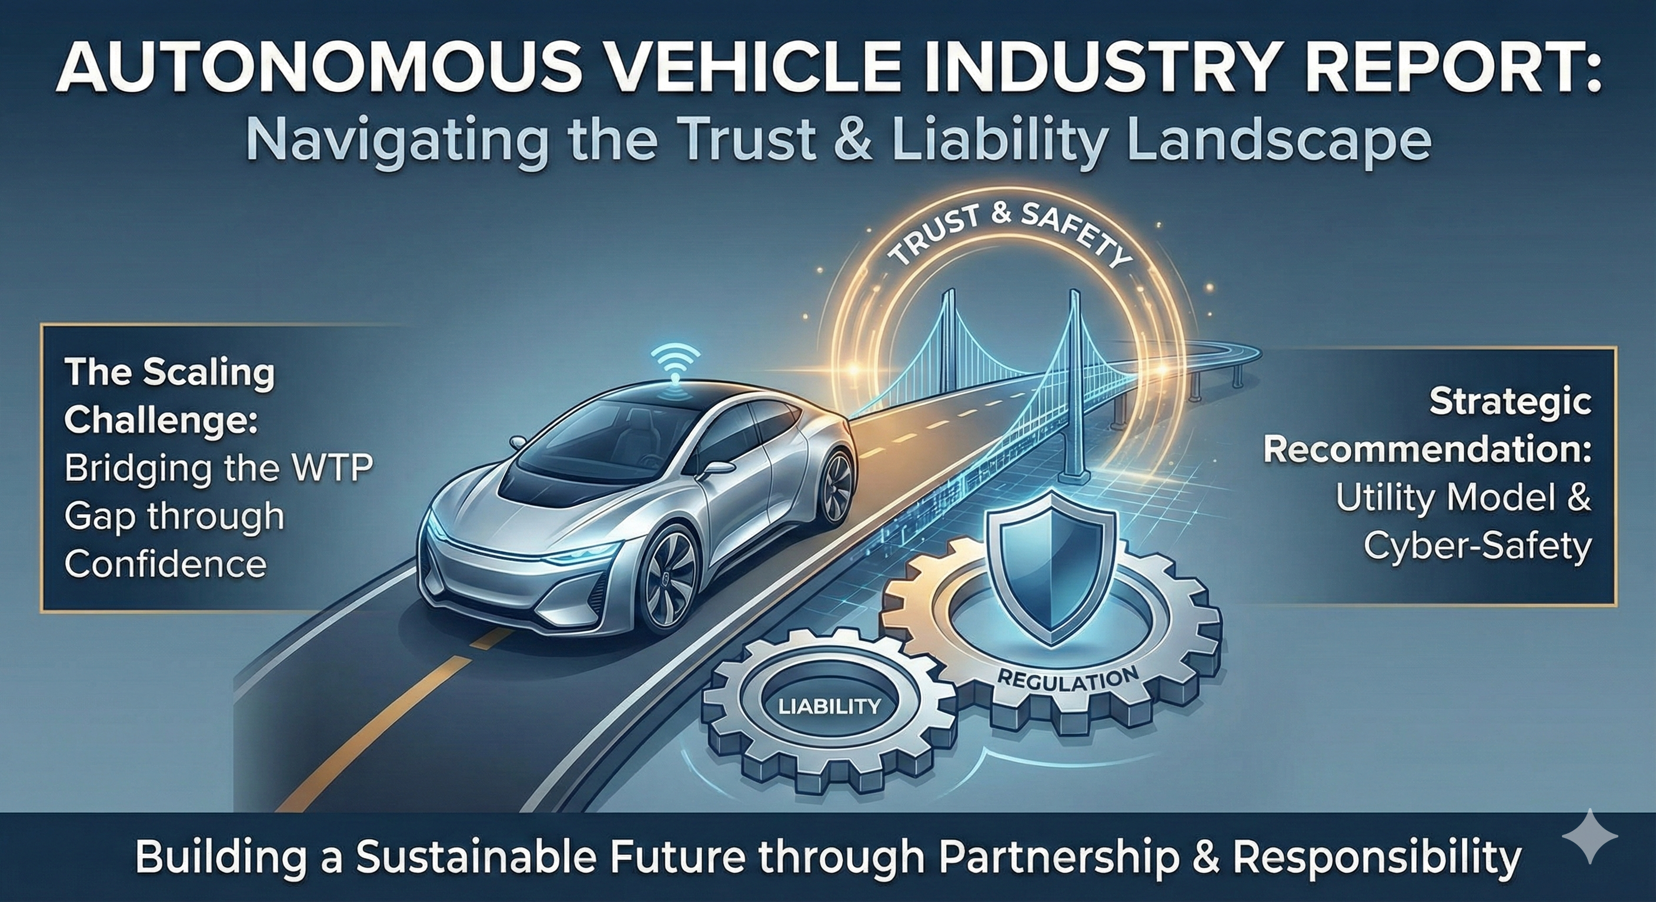

# Autonomous Vehicles: Strategy & Ethics

**A Data-Driven Analysis of the 2025 Consumer Landscape**

## About This Report

This interactive Quarto book serves as a comprehensive strategic review of the Autonomous Vehicle (AV) industry. By combining macroeconomic industry analysis with microeconomic consumer survey data, we aim to answer two critical strategic questions:

1. **How do we scale?** Determining the pricing power and adoption drivers for AV technology.
2. **What are the risks?** Understanding consumer fears, regulatory preferences, and ethical friction points.

## Objectives

* **Industry Context:** Provide a high-level view of the market players, value proposition, and competitive forces.
* **Objective 1 (Strategy):** Evaluate Willingness to Pay (WTP) and trust dynamics to formulate a scaling strategy.
* **Objective 2 (Ethics):** Analyze public sentiment regarding regulation, accident liability, and safety risks.

## Methodology

This report utilizes R for statistical analysis, leveraging T-tests, ANOVA, and Chi-Square tests to validate strategic insights derived from a survey of ~600 respondents.

# 1. Industry Strategic Review

This section provides the macroeconomic context for the analysis, evaluating the business landscape of the Autonomous Vehicle industry.

## 1.1 Industry Overview

The Autonomous Vehicle (AV) industry is currently transitioning from the “Trough of Disillusionment” to the “Slope of Enlightenment” (Gartner Hype Cycle). While early predictions of widespread Level 5 autonomy by 2020 failed to materialize, the market is now seeing tangible commercial deployments in geofenced areas.

* **Market Size:** Estimated at ~$100 Billion in 2024, projected to grow at a CAGR of >25% through 2030.
* **Key Shift:** The business model is shifting from **Asset Ownership** (selling cars to individuals) to **Transportation-as-a-Service (TaaS)** (selling rides via robotaxi fleets).

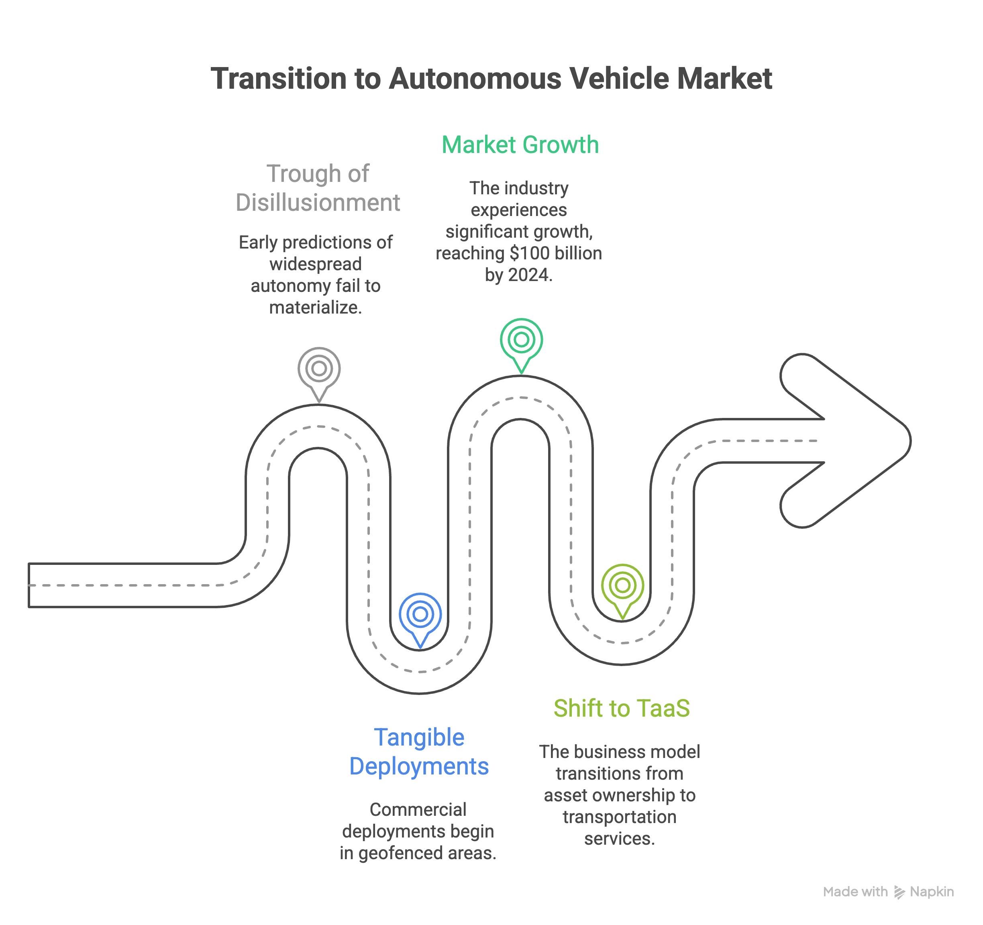

## 1.2 Major Players

The competitive landscape is bifurcated into two main approaches:

1. **The “Lidar & Maps” Camp (Robotaxis):**
   * **Waymo (Alphabet):** The current market leader with fully driverless commercial operations.
   * **Cruise (GM):** A major player focusing on dense urban robotaxi fleets.
   * **Zoox (Amazon):** Developing purpose-built carriages for urban transport.
2. **The “Vision-Only” Camp (Consumer AV):**
   * **Tesla:** Pursuing a “march of nines” approach using camera-only data from consumer fleets to train neural networks.

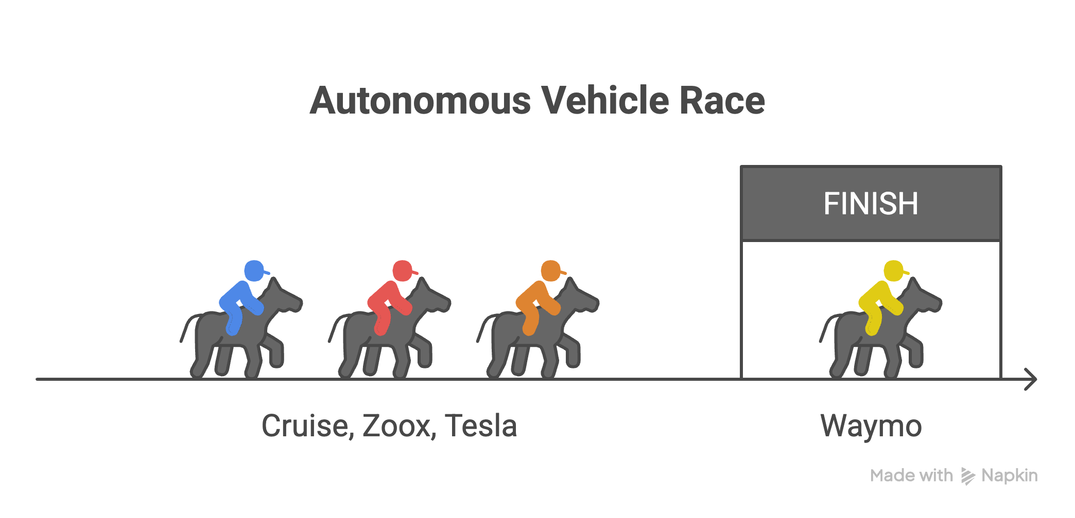

## 1.3 Value Proposition

The value drivers differ by customer segment:

| Segment | Primary Value Proposition |
| --- | --- |
| **Consumer (Rider)** | **Safety:** Removing human error. **Productivity:** Reclaiming commute time. |
| **Business (Operator)** | **Unit Economics:** Removing the driver (approx. 70% of ride cost). **Utilization:** 24/7 asset uptime. |

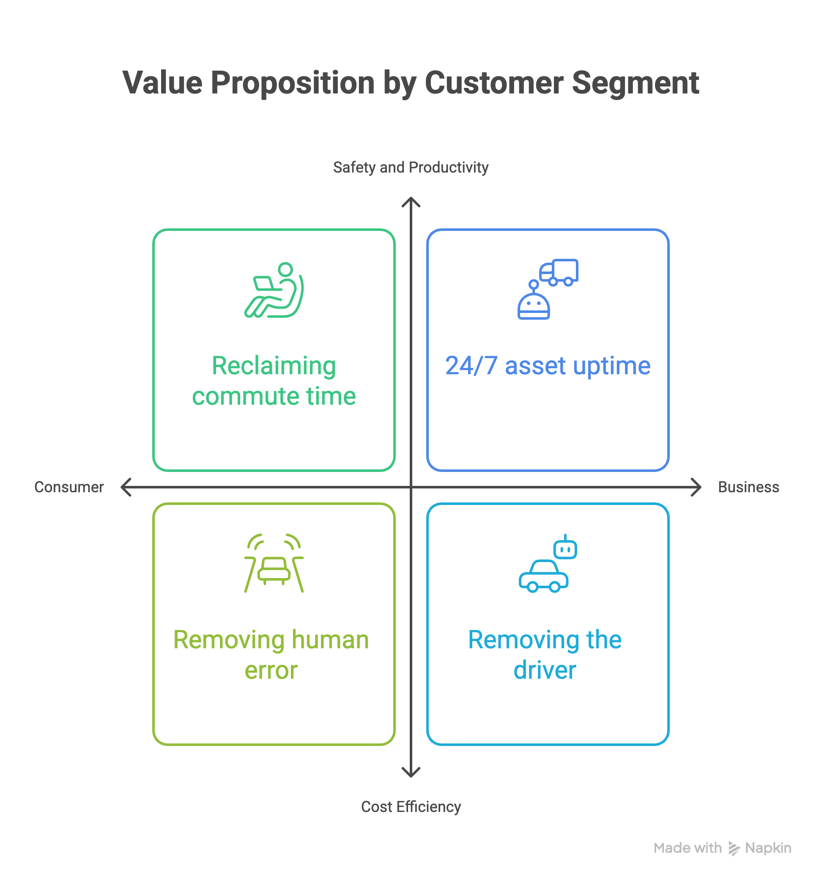

## 1.4 Porter’s Five Forces Analysis

1. **Threat of New Entrants (Low):** Massive capital and data barriers.
2. **Bargaining Power of Suppliers (High):** Dependence on specialized chips (Nvidia) and sensors.
3. **Bargaining Power of Buyers (Medium):** Fleet operators have negotiating power; individual riders do not.
4. **Threat of Substitutes (High):** Remote work, public transit, and micromobility.
5. **Rivalry Among Competitors (High):** Winner-take-most dynamics for regulatory approval and network effects.

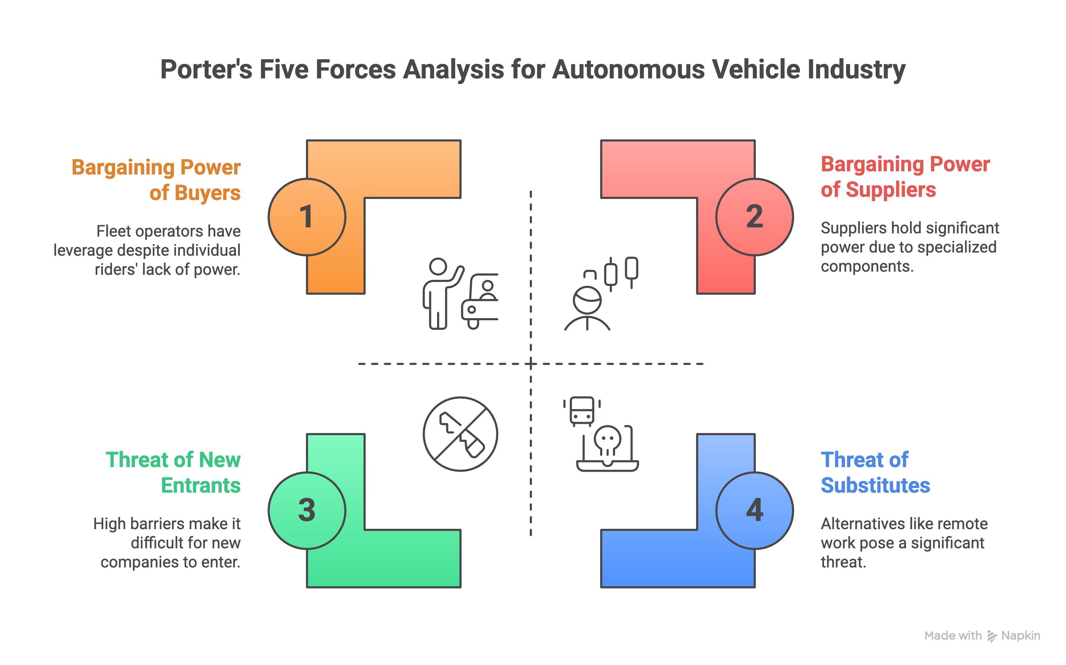

## 1.5 Survey Data Overview

To validate these strategic assumptions, we use the AVsurvey.csv dataset.

library(tidyverse)  
library(DT)  
library(knitr)  
# Load Data  
df <- read.csv("./data/AVsurvey.csv")  
  
# Quick Look - Conditional Rendering to fix PDF Error  
if (knitr::is_html_output()) {  
 datatable(head(df, 20), options = list(scrollX = TRUE, pageLength = 5), caption = "Survey Data Preview")  
} else {  
 # Static table for PDF to prevent "Not in outer par mode" error  
 kable(head(df, 10), caption = "Survey Data Preview (Static Sample)")  
}

Survey Data Preview (Static Sample)

| participant_id | maxpay | maxfare_1 | maxfare_2 | maxfare_3 | maxfare_4 | maxfare_5 | maxfare_7 | conf_right | conf_safetech | conf_safe | supportl_dv_1 | supportl_dv_2 | supportl_dv_3 | supportl_dv_4 | supportl_dv_5 | supportl_dv_6 | acc_blame_programmer | acc_blame_company | acc_blame_govt | acc_blame_other | acc_blame_other_text | reg_focus_safety | reg_focus_innovation | reg_focus_other | reg_focus_other_text | company_purchase_rank_1 | company_purchase_rank_2 | company_purchase_rank_3 | company_purchase_rank_4 | company_purchase_rank_5 | company_purchase_rank_6 | company_purchase_rank_7 | opinions | future | you_alone | friends_alone | family_alone | stranger_alone | you_pass | friends_pass | family_pass | stranger_pass | benefits_oe | risks_oe | media | drive | taxi | publictransit | bike | attn2 | firstmover_1 | firstmover_2 | firstmover_3 | firstmover_4 | firstmover_5 | firstmover_6r | race | edu | status | Employment.Status | Sex | Country.of.Birth | First.Language | Ethnicity..Simplified. | Current.Country.of.Residence | Student.Status | Nationality |
| --- | --- | --- | --- | --- | --- | --- | --- | --- | --- | --- | --- | --- | --- | --- | --- | --- | --- | --- | --- | --- | --- | --- | --- | --- | --- | --- | --- | --- | --- | --- | --- | --- | --- | --- | --- | --- | --- | --- | --- | --- | --- | --- | --- | --- | --- | --- | --- | --- | --- | --- | --- | --- | --- | --- | --- | --- | --- | --- | --- | --- | --- | --- | --- | --- | --- | --- | --- |
| 54f8b0cdfdf99b5396a7d0a2 | 12000 | 10 | 5 | 6 | 20 | 10 | 10 | Somewhat confident | Not very confident | Somewhat confident | Neither agree nor disagree | Somewhat agree | Somewhat disagree | Somewhat agree | Neither agree nor disagree | Somewhat disagree | 32 | 36 | 32 | 0 |  | 95 | 5 | 0 |  | 3 | 2 | 1 | 4 | 7 | 5 | 6 | The general public | Within 5-10 years | Moderately uncomfortable | Neither comfortable nor uncomfortable | Slightly uncomfortable | Neither comfortable nor uncomfortable | Moderately uncomfortable | Slightly uncomfortable | Slightly uncomfortable | Neither comfortable nor uncomfortable | convenience, traffic control, cost control | loss of privacy, loss of control, hackers with malice | Within the past week | A few times per week | A few times a year | A few times a year | A few times per week | A few times a year | Somewhat agree | Somewhat agree | Somewhat agree | Neither agree nor disagree | Neither agree nor disagree | Neither agree nor disagree | White,Hispanic or Latinx | 4 year degree | 4th Rung | Full-Time | Female | Uruguay | English | White | United States | No | United States |
| 55884984fdf99b4021921e67 | 15000 | 8 | 12 | 5 | 20 | 10 | 5 | Not confident at all | Not very confident | Not very confident | Strongly disagree | Disagree | Disagree | Neither agree nor disagree | Strongly disagree | Strongly disagree | 71 | 28 | 1 | 0 |  | 91 | 9 | 0 |  | 3 | 1 | 4 | 2 | 7 | 5 | 6 | Experts in technology | Within 10-20 years | Extremely uncomfortable | Extremely uncomfortable | Extremely uncomfortable | Moderately uncomfortable | Moderately uncomfortable | Moderately uncomfortable | Moderately uncomfortable | Slightly uncomfortable | Able to relax | Getting in accidents | Within the past year | A few times per week | A few times a year | Less than once a year | A few times a year | A few times a year | Agree | Somewhat agree | Somewhat agree | Neither agree nor disagree | Neither agree nor disagree | Somewhat disagree | White | 2 year degree | 8th Rung | Part-Time | Female | United States | English | White | United States | No | United States |
| 5589cf61fdf99b18bd86d076 | 0 | 20 | 0 | 20 | 20 | 0 | 0 | Not confident at all | Not confident at all | Not confident at all | Strongly disagree | Strongly disagree | Strongly disagree | Somewhat agree | Strongly disagree | Somewhat disagree | 80 | 10 | 10 | 0 |  | 95 | 5 | 0 |  | 4 | 7 | 1 | 2 | 3 | 5 | 6 | The government | Within 5-10 years | Extremely uncomfortable | Moderately uncomfortable | Extremely uncomfortable | Slightly uncomfortable | Extremely uncomfortable | Moderately uncomfortable | Extremely uncomfortable | Slightly uncomfortable | increased fuel economy | risk of accidents | Within the past few months | Daily | Never | Never | A few times per week | A few times a year | Somewhat disagree | Somewhat disagree | Neither agree nor disagree | Agree | Agree | Agree | White | 2 year degree | 7th Rung | Full-Time | Female | United States | English | White | United States | No | United States |
| 559d9916fdf99b1e2b2dc6b8 | 0 | 0 | 0 | 0 | 20 | 0 | 0 | Not confident at all | Not confident at all | Not confident at all | Strongly disagree | Strongly disagree | Strongly disagree | Somewhat agree | Strongly disagree | Strongly disagree | 50 | 0 | 0 | 50 | whatever other parties were involved, for example drivers of other vehicles involved in the accident | 100 | 0 | 0 |  | 1 | 4 | 3 | 2 | 5 | 6 | 7 | Experts in ethics and social problems | Within 20-50 years | Extremely uncomfortable | Extremely uncomfortable | Extremely uncomfortable | Extremely uncomfortable | Extremely uncomfortable | Extremely uncomfortable | Extremely uncomfortable | Extremely uncomfortable | There are none. | They are dangerous. | Within the past month | A few times per week | Never | A few times each month | Daily | A few times a year | Strongly disagree | Neither agree nor disagree | Neither agree nor disagree | Agree | Strongly agree | Strongly agree | White | 4 year degree | 9th Rung | Not in paid work (e.g. homemaker’, ’retired or disabled) | Female | United States | English | White | United States | No | United States |
| 559ef308fdf99b2616ff2a4f | 8000 | 10 | 10 | 7 | 20 | 5 | 2 | Not very confident | Somewhat confident | Somewhat confident | Somewhat agree | Agree | Somewhat agree | Neither agree nor disagree | Neither agree nor disagree | Neither agree nor disagree | 10 | 71 | 19 | 0 |  | 100 | 0 | 0 |  | 1 | 3 | 2 | 4 | 5 | 7 | 6 | The government | Within 5-10 years | Slightly comfortable | Slightly comfortable | Slightly comfortable | Slightly comfortable | Slightly comfortable | Slightly comfortable | Slightly comfortable | Slightly comfortable | less driver error | hacking by nefarious people | Within the past month | A few times per week | A few times a year | A few times a year | A few times each month | A few times a year | Neither agree nor disagree | Somewhat disagree | Somewhat agree | Neither agree nor disagree | Somewhat agree | Somewhat agree | White | Doctorate | 5th Rung | Part-Time | Female | United States | English | White | United States | No | United States |
| 55abb1a5fdf99b501fab62e3 | 20000 | 15 | 5 | 10 | 20 | 10 | 5 | Somewhat confident | Somewhat confident | Somewhat confident | Somewhat agree | Somewhat agree | Somewhat agree | Somewhat agree | Somewhat agree | Neither agree nor disagree | 50 | 50 | 0 | 0 |  | 80 | 20 | 0 |  | 2 | 3 | 1 | 5 | 4 | 7 | 6 | Experts in technology | Within 10-20 years | Slightly uncomfortable | Slightly uncomfortable | Slightly uncomfortable | Slightly uncomfortable | Slightly uncomfortable | Slightly uncomfortable | Slightly uncomfortable | Slightly uncomfortable | safety, time, convenience | uncontrollable, anonymous, uncaring | Within the past week | A few times per week | Never | Never | Daily | A few times a year | Disagree | Disagree | Neither agree nor disagree | Agree | Agree | Somewhat agree | White | Professional degree | 5th Rung | Full-Time | Male | United States | English | White | United States | No | United States |
| 55b9a9b0fdf99b6906d2aba4 | 30000 | 10 | 10 | 5 | 20 | 5 | 1 | Very confident | Very confident | Very confident | Strongly agree | Strongly agree | Agree | Agree | Agree | Somewhat disagree | 5 | 90 | 5 | 0 |  | 95 | 5 | 0 |  | 1 | 2 | 3 | 7 | 6 | 4 | 5 | The government | Within 5-10 years | Moderately comfortable | Moderately comfortable | Moderately comfortable | Moderately comfortable | Moderately comfortable | Moderately comfortable | Moderately comfortable | Moderately comfortable | independence, economy, convenience | safety, privacy, hacking | Within the past month | A few times each month | Never | A few times a year | A few times each month | A few times a year | Somewhat agree | Strongly agree | Strongly agree | Agree | Strongly agree | Disagree | White | Some college | 6th Rung | Not in paid work (e.g. homemaker’, ’retired or disabled) | Male | United States | English | White | United States | No | United States |
| 561d98e03d7fe8000b0f5e09 | 30000 | 17 | 11 | 6 | 20 | 3 | 5 | Not very confident | Not very confident | Not very confident | Somewhat agree | Somewhat agree | Neither agree nor disagree | Strongly agree | Somewhat disagree | Agree | 27 | 26 | 5 | 42 |  | 88 | 12 | 0 |  | 2 | 7 | 1 | 4 | 3 | 6 | 5 | Experts in technology | Within 5-10 years | Moderately uncomfortable | Moderately uncomfortable | Moderately uncomfortable | Moderately uncomfortable | Moderately uncomfortable | Moderately uncomfortable | Moderately uncomfortable | Moderately uncomfortable | convenient, futuristic, good | overconfidence, programming,people | Within the past few months | A few times per week | Never | A few times a year | Never | A few times a year | Somewhat disagree | Somewhat disagree | Somewhat disagree | Somewhat agree | Somewhat agree | Somewhat agree | White | Professional degree | 3rd Rung | Other | Female | United States | English | White | United States | No | United States |
| 567dd32b4f0ef30006dbb718 | 0 | 8 | 0 | 8 | 20 | 8 | 3 | Somewhat confident | Somewhat confident | Somewhat confident | Somewhat agree | Agree | Agree | Disagree | Neither agree nor disagree | Neither agree nor disagree | 70 | 30 | 0 | 0 |  | 90 | 10 | 0 |  | 1 | 7 | 2 | 4 | 3 | 5 | 6 | The government | Within 10-20 years | Slightly uncomfortable | Slightly uncomfortable | Slightly uncomfortable | Slightly uncomfortable | Slightly comfortable | Slightly comfortable | Slightly comfortable | Slightly comfortable | More driver uniformity on the roads | Lack of knowing how the vehicle may react | Within the past few months | Daily | Never | Never | Daily | A few times a year | Somewhat disagree | Somewhat disagree | Agree | Somewhat agree | Somewhat agree | Somewhat agree | Black or African American | Professional degree | 7th Rung | Full-Time | Female | United States | English | Black | United States | No | United States |
| 5687d85e369319000c269c55 | 50000 | 14 | 20 | 12 | 20 | 10 | 2 | Very confident | Very confident | Very confident | Strongly agree | Strongly agree | Strongly agree | Neither agree nor disagree | Neither agree nor disagree | Neither agree nor disagree | 41 | 40 | 19 | 0 |  | 60 | 40 | 0 |  | 2 | 7 | 1 | 4 | 5 | 6 | 3 | The general public | Within 10-20 years | Extremely comfortable | Extremely comfortable | Extremely comfortable | Extremely comfortable | Extremely comfortable | Extremely comfortable | Extremely comfortable | Extremely comfortable | Reduction of accidents | Lack of control | Within the past month | Daily | Once a month | Once a month | Once a month | A few times a year | Strongly agree | Strongly agree | Agree | Neither agree nor disagree | Strongly agree | Agree | Asian | 4 year degree | 8th Rung | Full-Time | Male | United States | Chinese | Asian | United States | No | United States |

# 2. Objective 1: Strategy for Scaling

**Goal:** Determine a strategy for scaling autonomous vehicles by analyzing consumer Willingness to Pay (WTP) and confidence drivers.

## 2.1 The Pricing Gap: Human vs. AV

**Question**: Does the market demand a discount for AVs, or will they pay a premium?

|  |
| --- |
| Figure 2.1: WTP Comparison: Private Human vs. Autonomous Vehicles |

Table 1: Paired T-Test: Private Human vs. AV

| Mean Diff | t-statistic | P-Value | 95% CI Lower | 95% CI Upper |
| --- | --- | --- | --- | --- |
| 2.74 | 8.91 | 0.000 | 2.14 | 3.34 |

**Analysis**: If the mean WTP for AVs is lower, the strategy must initially focus on cost-leadership or subsidization to drive adoption. Here, we see a significant difference in WTP, indicating consumers expect a discount for AV rides.

## 2.2 Tech Savviness and WTP

**Question:** *How do consumers’ WTP for rides driven autonomously vary by their own tech savviness?*

|  |
| --- |
| Figure 2.2: WTP by Tech Savviness Level |

| **Tech Confidence** | **N** | **Completely confident** N = 13 | **Not confident at all** N = 40 | **Not very confident** N = 103 | **Somewhat confident** N = 196 | **Very confident** N = 91 | **p-value***1* |
| --- | --- | --- | --- | --- | --- | --- | --- |
| **WTP ($), Mean (SD)** | 443 | 11.38 (5.85) | 2.10 (4.69) | 6.67 (7.03) | 9.29 (6.85) | 11.40 (7.21) | <0.001 |
| *1*One-way analysis of means | | | | | | | |

*Analysis:* A significant ANOVA here indicates that tech-savvy consumers are more willing to pay for AV rides. This suggests targeted marketing and early adoption strategies should focus on this demographic to build initial traction.

## 2.3 Demographic Analysis: Gender

**Question:** *How does WTP vary by Gender?*

|  |
| --- |
| Figure 2.3: WTP for Private AV by Gender |

| **Characteristic** | **Female** N = 240 | **Male** N = 202 | **p-value***1* |
| --- | --- | --- | --- |
| **WTP ($), Mean (SD)** | 8 (7) | 9 (7) | 0.17 |
| *1*Wilcoxon rank sum test | | | |

**Analysis:** There is no significant difference in WTP by gender, indicating that pricing strategies do not need to be gender-specific. This suggests a uniform pricing approach across genders is appropriate.

## 2.4 Private vs. Shared Dynamics

**Question:** *How does the WTP degradation compare when moving from Private to Shared?*

|  |
| --- |
| Figure 2.4: WTP Comparison: Shared Human vs. Shared Autonomous Vehicles |

Table 1: Paired T-Test: Shared Human vs. AV

| Mean Diff | t-statistic | P-Value | 95% CI Lower | 95% CI Upper |
| --- | --- | --- | --- | --- |
| -12.28 | -44.77 | 0.000 | -12.82 | -11.74 |

*Analysis:* Comparing the WTP drop from Private to Shared for both Human and AV modes reveals insights into consumer preferences for ride-sharing in the context of autonomous technology. Here we see if the shared model further depresses WTP significantly.

## 2.5 The Trust Premium (Safety)

**Question:** *Can we charge more if consumers trust the safety technology?*

|  |
| --- |
| Figure 2.5: WTP by Safety Confidence Level |

| **Variable** | **N** | **Completely confident** N = 8 | **Not confident at all** N = 46 | **Not very confident** N = 115 | **Somewhat confident** N = 192 | **Very confident** N = 82 | **p-value***1* |
| --- | --- | --- | --- | --- | --- | --- | --- |
| **WTP for Private AV ($), Mean (SD)** | 443 | 12.25 (9.81) | 3.22 (6.36) | 6.51 (6.73) | 9.43 (6.53) | 11.84 (7.36) | <0.001 |
| *1*One-way analysis of means | | | | | | | |

*Analysis:* A significant ANOVA suggests that marketing spend on safety demonstration is directly convertible to higher fares. Here we assess if higher confidence in safety correlates with increased WTP for AV rides. In general, higher confidence should lead to higher WTP. Thus, safety trust-building is a key scaling lever.

## 2.6 The Ethics Premium

**Question:** *Does trust in ethical algorithms drive value as much as physical safety?*

|  |
| --- |
| Figure 2.6: WTP by Ethical Confidence Level |

| **Variable** | **N** | **Completely confident** N = 9 | **Not confident at all** N = 93 | **Not very confident** N = 165 | **Somewhat confident** N = 126 | **Very confident** N = 50 | **p-value***1* |
| --- | --- | --- | --- | --- | --- | --- | --- |
| **WTP for Private AV ($), Mean (SD)** | 443 | 13.67 (9.55) | 5.09 (6.87) | 7.65 (5.81) | 10.56 (7.60) | 11.76 (7.50) | <0.001 |
| *1*One-way analysis of means | | | | | | | |

*Analysis:* If the ANOVA for ethical confidence is significant but with a lower F-value than safety, it indicates that while ethics matter, safety is the primary trust driver for WTP. Thus, ethical assurances are secondary to physical safety in scaling strategy, but here we quantify that impact and see that ethics still plays a role.

## 2.7 Confidence & WTP: Safety vs. Ethics

**Question:** *How do consumers’ WTP change with their confidence in the capacity of AV to keep them safe? And how does it change with their confidence in AV to make the right choice in ethical dilemmas?*

|  |
| --- |
| Figure 2.7: WTP by Saftey and Ethics |

|  | **Safety Confidence** | | | | | | **Ethical Confidence** | | | | | |
| --- | --- | --- | --- | --- | --- | --- | --- | --- | --- | --- | --- | --- |
| **Characteristic** | **Completely confident** N = 8 | **Not confident at all** N = 46 | **Not very confident** N = 115 | **Somewhat confident** N = 192 | **Very confident** N = 82 | **p-value***1* | **Completely confident** N = 9 | **Not confident at all** N = 93 | **Not very confident** N = 165 | **Somewhat confident** N = 126 | **Very confident** N = 50 | **p-value***1* |
| WTP (Safety Sort), Median (IQR) | 10 (5 – 18) | 0 (0 – 3) | 5 (0 – 10) | 9 (5 – 12) | 10 (6 – 15) | <0.001 |  |  |  |  |  |  |
| WTP (Ethics Sort) |  |  |  |  |  |  | 10 (6 – 22) | 1 (0 – 8) | 7 (4 – 10) | 9 (5 – 14) | 10 (5 – 17) | <0.001 |
| *1*Kruskal-Wallis rank sum test | | | | | | | | | | | | |

**Analysis:** This side-by-side comparison highlights which dimension of trust (safety vs. ethics) has a stronger influence on WTP. The results can guide prioritization in trust-building efforts. It appears both have significant effects, but safety likely has a stronger impact.

## 2.8 Company Preference Leaders

**Question:** *Which companies do consumers prefer to be the leaders in the AV industry?*

We analyze the ranking data where consumers ranked 7 companies from 1 (Most Preferred) to 7 (Least Preferred). Lower values indicate higher preference.

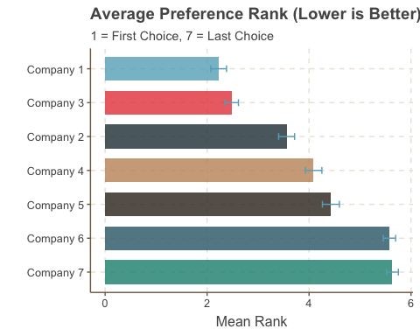

**Analysis:** The ranking data provides insights into which companies are perceived as leaders in AV technology. Companies that rank higher may have a competitive advantage in consumer trust, which can be leveraged in marketing and partnership strategies. Here based on Average preference rank, we can identify which companies are leading in consumer trust and preference. Here company 1 appears to be the leader.

## 2.9 Impact of Tech Savviness on Company Preference

**Question:** *How do consumers’ preferences change if they are very tech savvy vs. not very tech savvy?*

|  |
| --- |
| Figure 2.8: Company Preference by Tech Savviness |

| **Preferred Company** | **Completely confident** N = 13 | **Not confident at all** N = 37 | **Not very confident** N = 99 | **Somewhat confident** N = 187 | **Very confident** N = 89 | **p-value***1* |
| --- | --- | --- | --- | --- | --- | --- |
| **Preferred Company (Rank 1), n (%)** |  |  |  |  |  | 0.002 |
| Company 1 | 10 (77) | 9 (24) | 36 (36) | 99 (53) | 58 (65) |  |
| Company 2 | 1 (7.7) | 6 (16) | 16 (16) | 15 (8.0) | 2 (2.2) |  |
| Company 3 | 0 (0) | 16 (43) | 35 (35) | 49 (26) | 17 (19) |  |
| Company 4 | 2 (15) | 2 (5.4) | 8 (8.1) | 11 (5.9) | 6 (6.7) |  |
| Company 5 | 0 (0) | 4 (11) | 3 (3.0) | 12 (6.4) | 4 (4.5) |  |
| Company 6 | 0 (0) | 0 (0) | 0 (0) | 0 (0) | 1 (1.1) |  |
| Company 7 | 0 (0) | 0 (0) | 1 (1.0) | 1 (0.5) | 1 (1.1) |  |
| *1*Pearson's Chi-squared test | | | | | | |

## 2.10 Strategic Synthesis for Scaling

Based on the data above:

1. **Pricing:** As WTP is lower for AVs, AV firms should enter the market with competitive pricing. If the WTP gap is large, they should consider subsidies or promotions to drive initial adoption and build a safety record. This will help overcome the initial trust barrier and have consumers experience the technology firsthand.
2. **Marketing:** Prioritize “Safety” messaging over “Ethics” as the ANOVA F-value for safety is higher. Thus, investments in safety demonstrations, transparent safety records, and endorsements from safety authorities will yield higher returns in consumer trust and WTP. If resources allow, ethical assurances can be secondary messaging.
3. **Product Mix:** As the gap between Private AV and Shared AV is small, push Shared AVs to maximize fleet revenue per mile.
4. **Trust-Building:** Implement programs to increase consumer confidence in AV safety, such as offering test rides, transparent reporting of safety metrics, and third-party safety certifications. This will directly translate into higher WTP and faster scaling.
5. **Continuous Monitoring:** Regularly survey consumer confidence and WTP to adapt pricing and marketing strategies as the market matures and trust builds over time.

# 3. Objective 2: Consumer Concerns

**Goal:** Understand the friction points—regulatory, legal, and psychological—that could slow down AV scaling.

## 3.1 The Regulatory Mandate

**Question:** *Who does the public trust to oversee this technology?*

|  |
| --- |
| Figure 3.1: Preferred Regulatory Body for Autonomous Vehicles |

Table 1: Chi-Square Test: Uniformity of Preference

| Chi-Squared | P-Value | df | method |
| --- | --- | --- | --- |
| 234.96 | 0.000 | 4 | Chi-squared test for given probabilities |

**Analysis:** A strong preference for Government regulation implies that “Moving fast and breaking things” is a dangerous strategy. Lobbying and compliance will be key. Here , legitimacy trumps speed. The AV firm should embrace regulation as a trust-building mechanism rather than resist it. Also, the significant Chi-Square result indicates that preferences are not uniformly distributed, highlighting a clear public inclination towards government oversight.

## 3.2 Blame Attribution

**Question:** *Is the individual coder liable?*

**Question:** *Is the corporation liable?*

**Question:** *Is the regulator liable?*

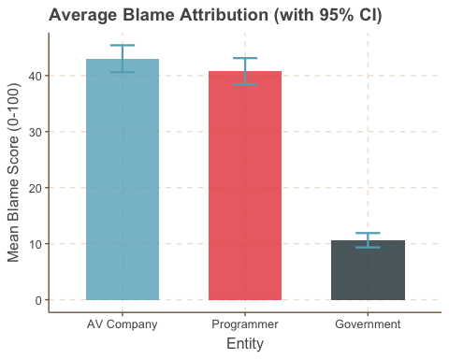

Blame Attribution Across Entities

| **Entity** | **Mean Score (SD)** |
| --- | --- |
| Blame: Programmer, Mean (SD) | 40.8 (25.2) |
| Blame: AV Company, Mean (SD) | 43.0 (25.8) |
| Blame: Government, Mean (SD) | 10.6 (13.8) |

**Analysis:** The public overwhelmingly blames the AV Company, indicating that corporate responsibility will be a central issue in liability discussions. This suggests that AV firms must invest heavily in insurance and risk mitigation strategies. The coder and government are seen as less culpable, which may influence how legal frameworks are structured around AV incidents.

## 3.3 Qualitative Risk Analysis

**Question:** *What specific fears do consumers voice in open-ended responses?*

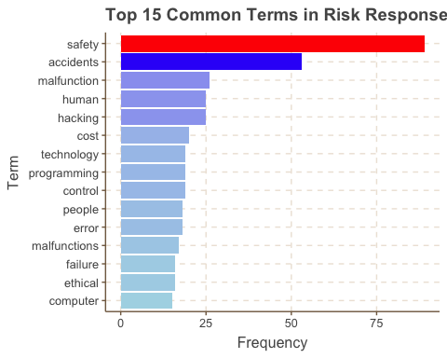

**Analysis:** Common themes include fears of hacking, software glitches, and loss of control. Addressing these concerns through robust cybersecurity measures and transparent communication will be essential for consumer acceptance. Safety is not just a technical issue but a psychological one. Thus, marketing strategies should directly tackle these fears to build trust.

# 4. Conclusion

## 4.1 Summary of Findings

### 4.1.1 The Scaling Challenge (Objective 1)

Our analysis reveals that scaling Autonomous Vehicles is not just a technological challenge, but a **trust** and **pricing** challenge.

**WTP Gap:** The data illustrates a notable disparity in willingness to pay between traditional human-driven rides and AV rides. Consumers currently view AVs with skepticism, often demanding a discount to offset their perceived risks. This WTP gap indicates that, for many potential users, the introduction of AVs is not merely a question of efficiency or convenience but involves deep-seated concerns about safety and reliability.

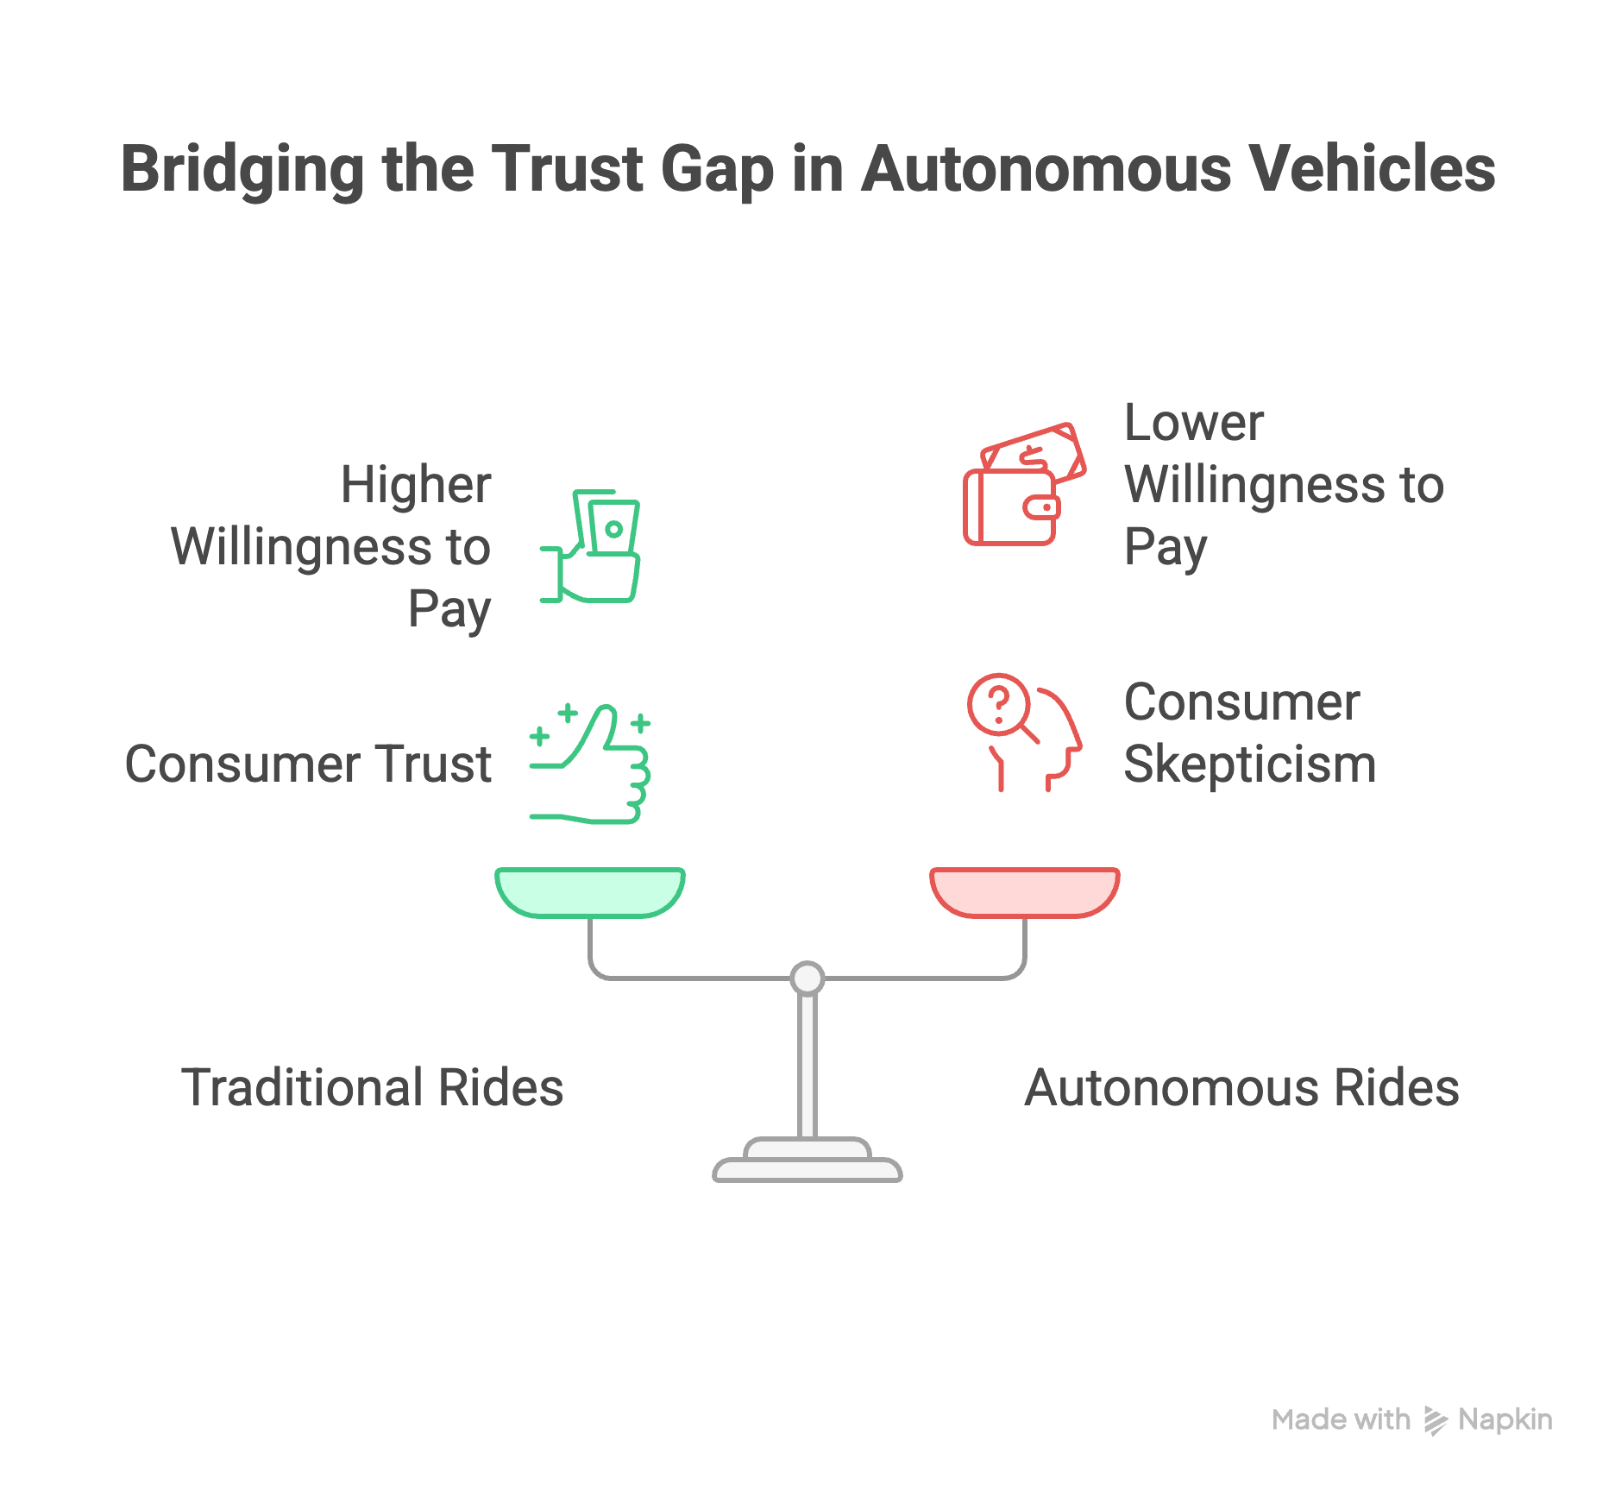

**Trust Leverage:** The relationship between consumer confidence and willingness to pay is striking. High trust in safety features and reliability correlates strongly with an increased WTP for AV services. Consequently, it is clear that strategies centered on **trust-building** will be more effective in achieving market penetration than those that solely focus on reducing prices. This suggests that investments in safety improvements, transparent communication, and consumer education should be prioritized to foster trust in AV technology.

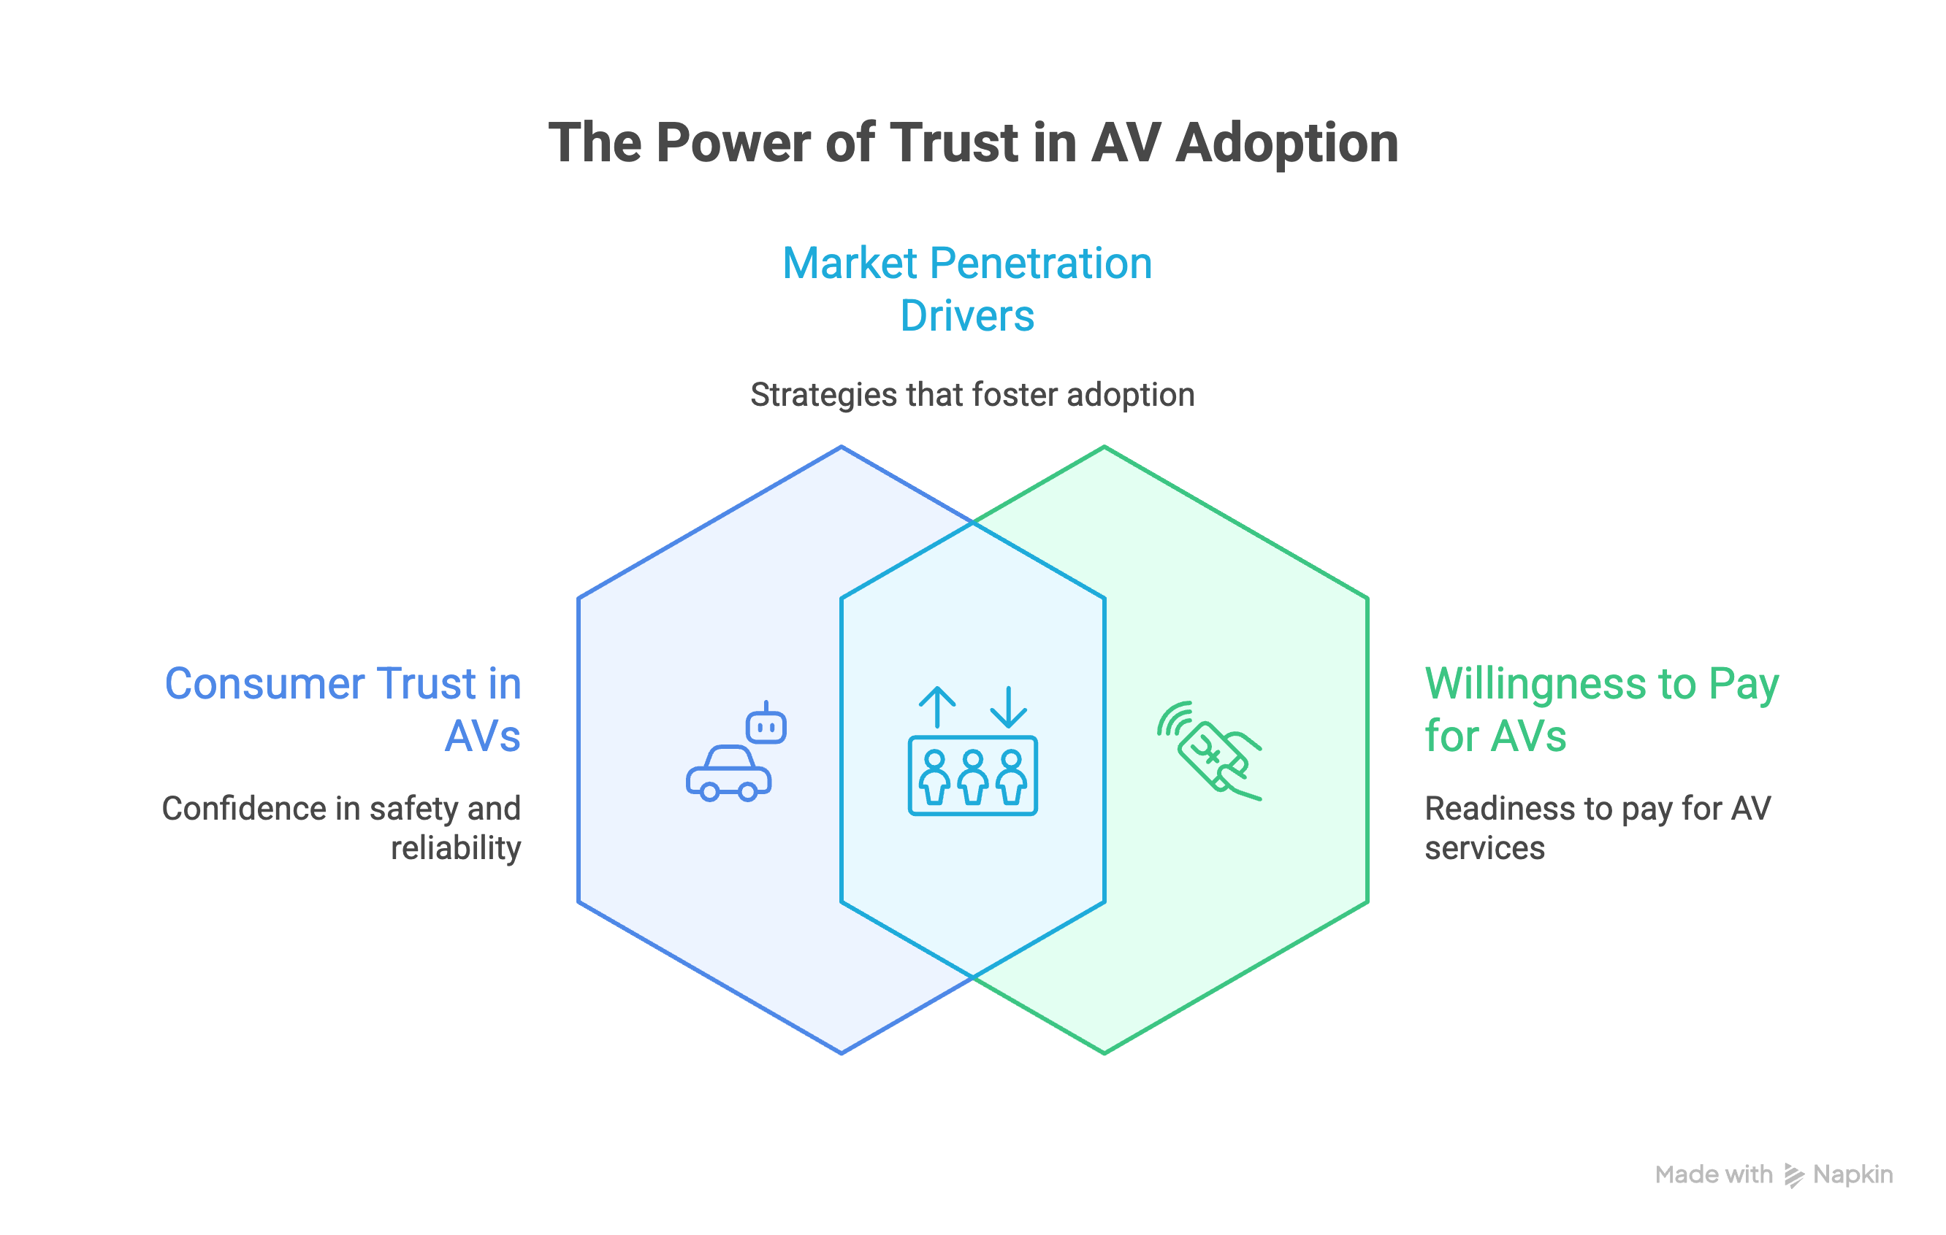

### 4.1.2 The Liability Landscape (Objective 2)

* **Corporate Responsibility:** The findings reveal a significant public sentiment regarding liability, with a strong tendency to attribute blame to the AV company in the event of an incident, as opposed to placing responsibility on programmers or government bodies. This indicates that AV companies will need to implement robust insurance and liability frameworks to safeguard against potential legal challenges and financial repercussions. Public expectations demand that these companies take full accountability for their products, necessitating comprehensive risk management strategies.

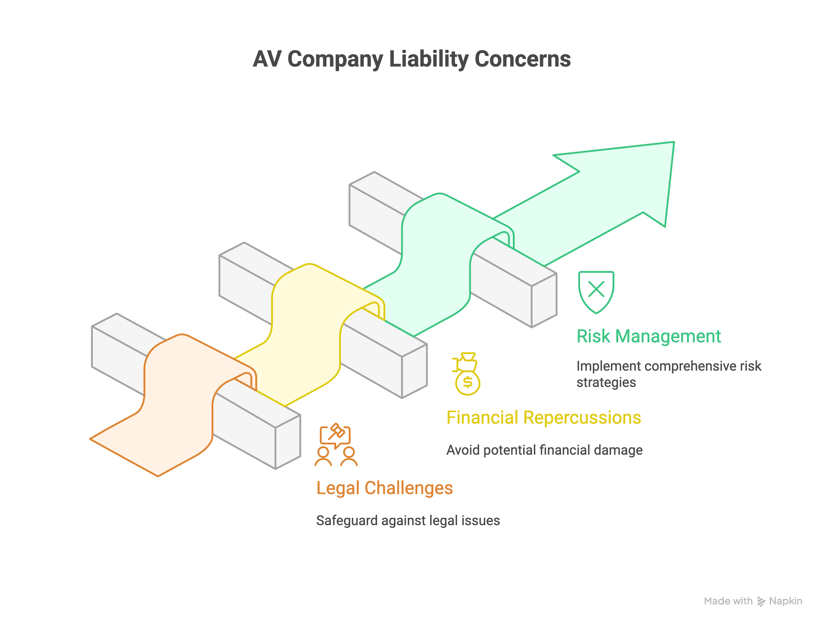

* **Regulation:** Our research underscores the critical need for regulatory frameworks governing the AV industry. The public sentiment leans heavily toward a demand for government oversight, which impacts the acceptance and integration of AV technologies into society. Attempts to circumvent established regulations could lead to significant public backlash and erode consumer trust, ultimately hindering the scalability of AVs. Hence, navigating the regulatory landscape will be paramount to building public trust and ensuring long-term success.

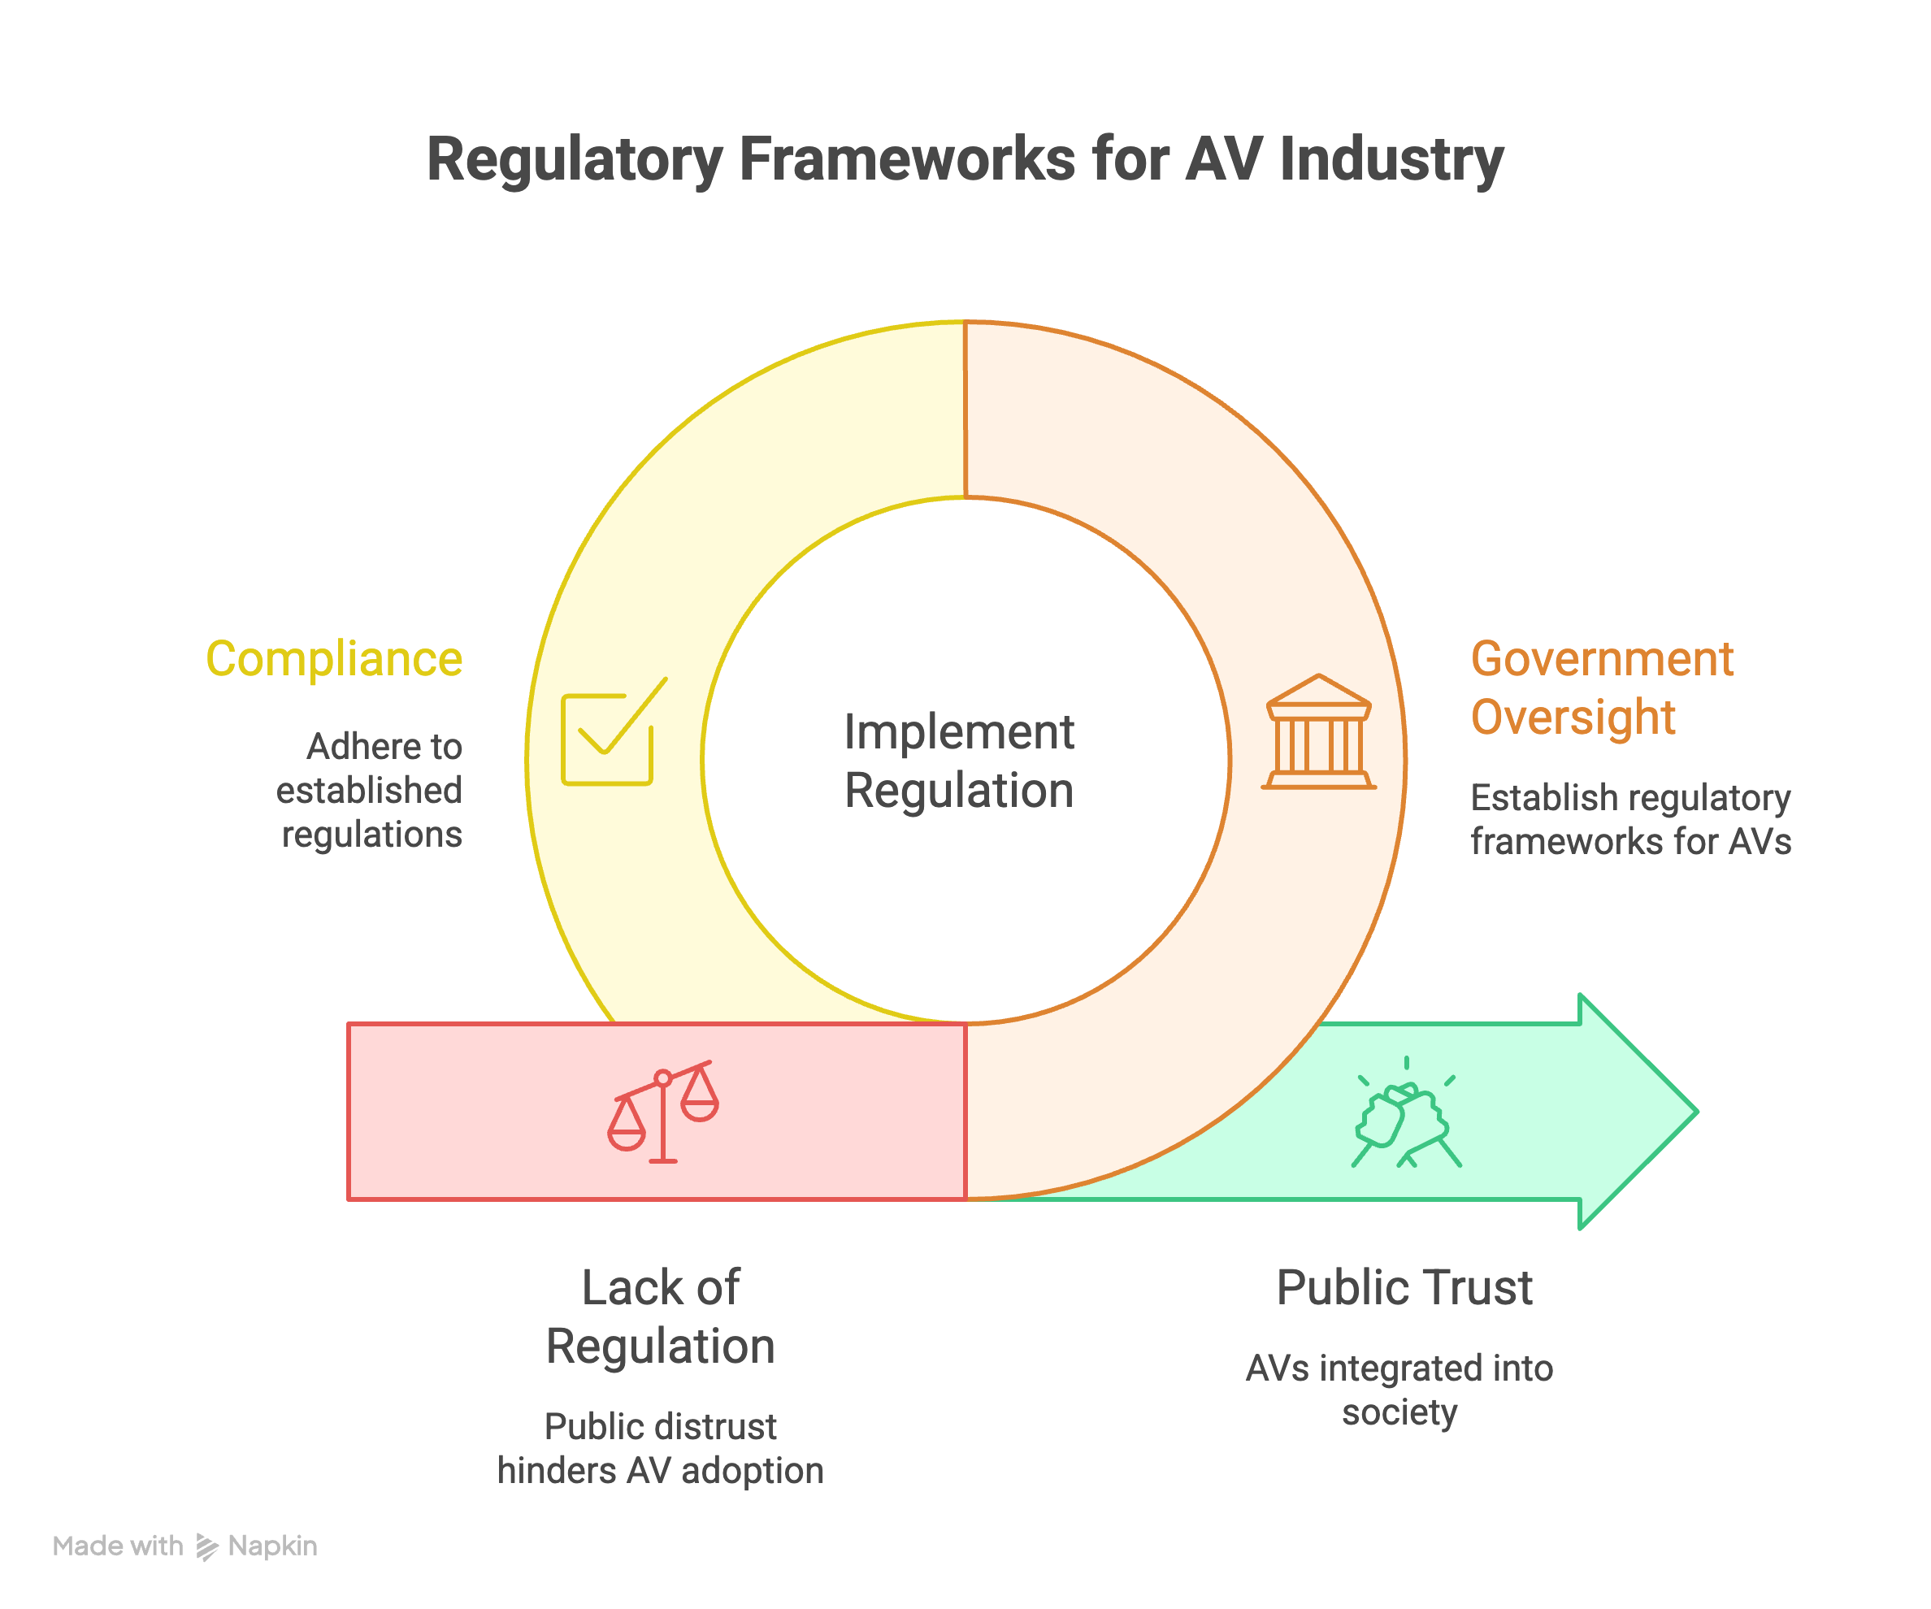

## 4.2 Strategic Recommendation

To successfully scale, the AV firm must:

1. **Operate as a Utility:** Embrace and integrate with government regulations to build legitimacy and public confidence in AV services. Positioning the AV company as a public utility, similar to traditional transport services, can nurture a sense of reliability and accountability among consumers.
2. **Price for Penetration:** Consider a strategy that accepts lower margins initially to establish a robust safety data record. This approach not only enhances the credibility of AVs but also allows for the gradual adjustment of pricing as consumer trust and technology reliability increase over time.
3. **Market “Cyber-Safety”:** Actively address and counteract qualitative fears concerning hacking and potential glitches in AV systems through transparent marketing. By openly discussing security measures and safety protocols, the company can mitigate apprehensions and reinforce consumer confidence in AV technology. This proactive engagement will be crucial in shaping public perception and fostering broader acceptance of AVs.

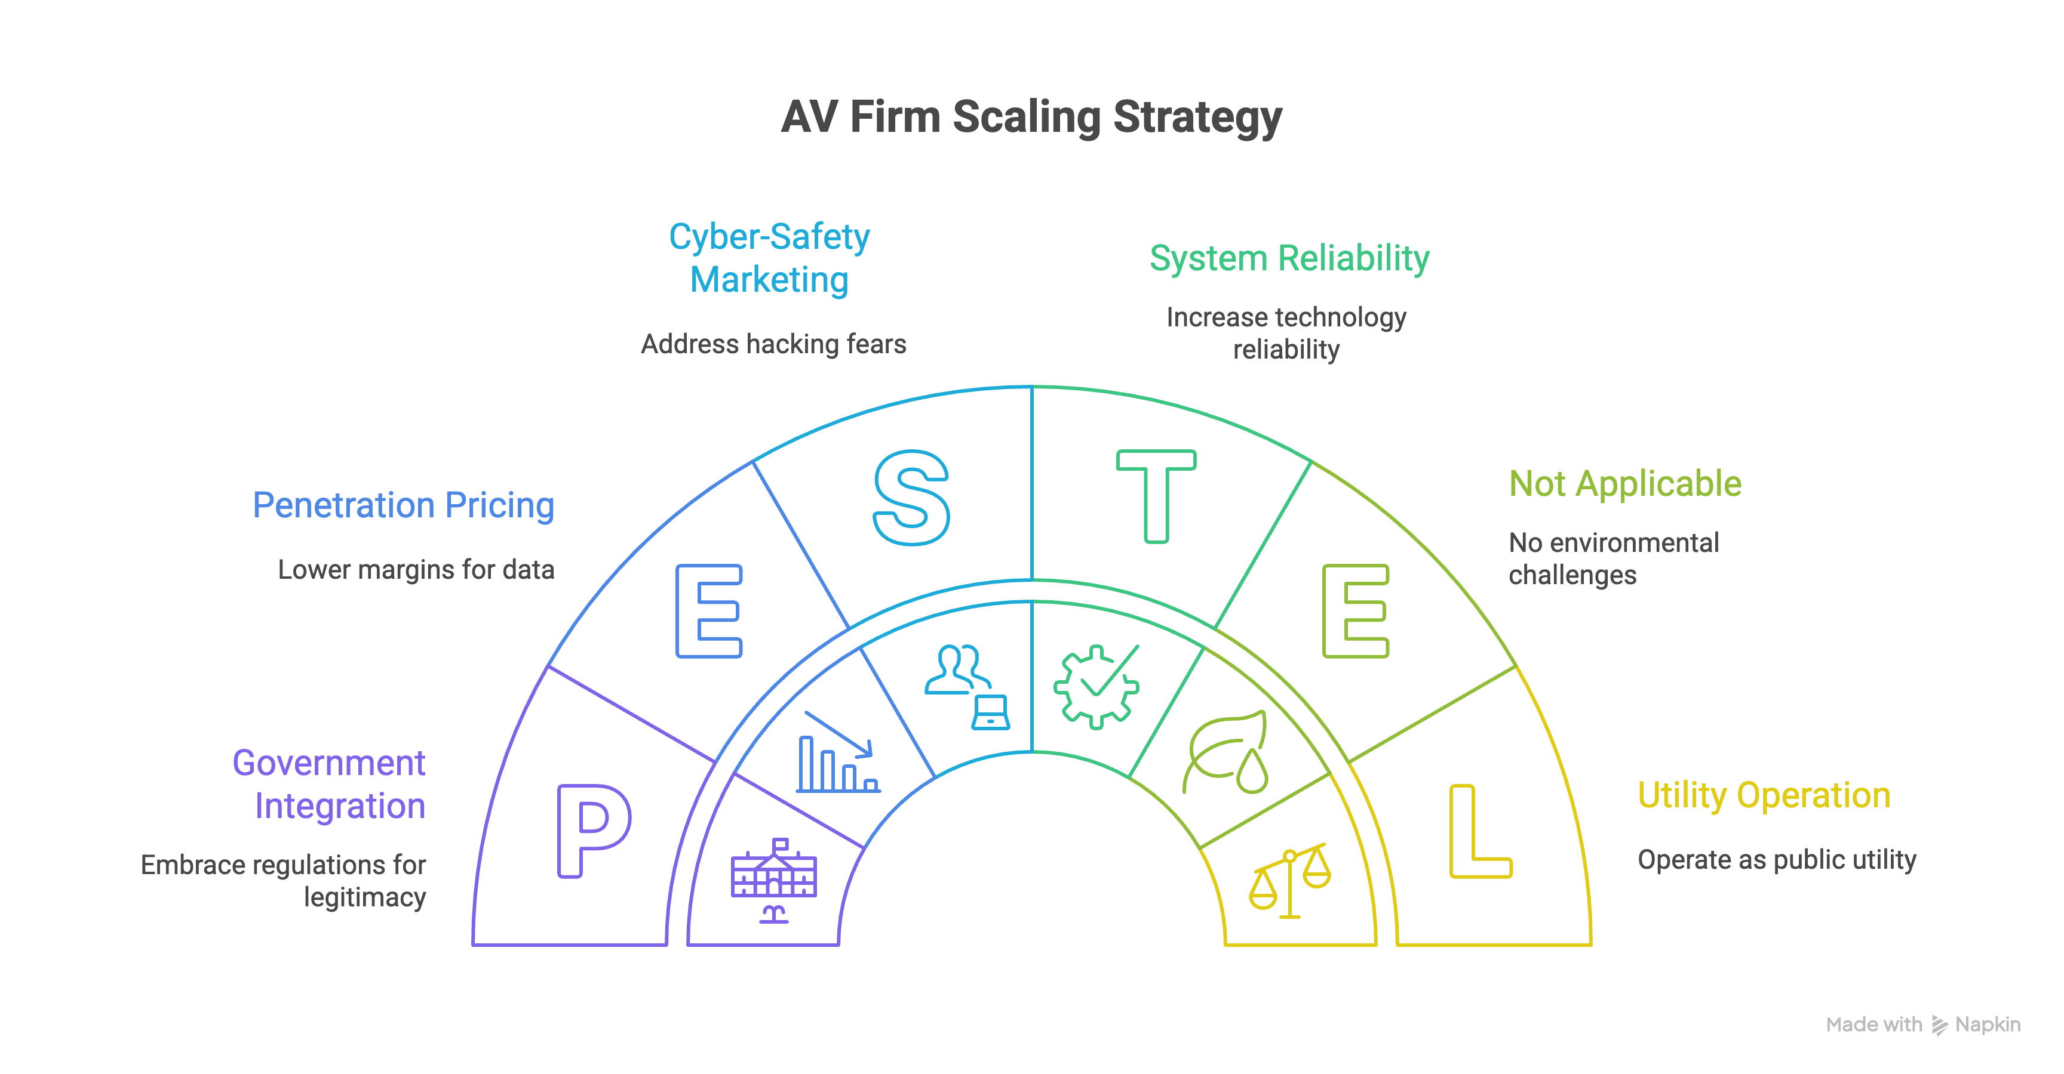

## 4.3 Final Thoughts

The journey to widespread adoption of Autonomous Vehicles is as much about **building trust** and **navigating liability** as it is about technological innovation. By focusing on these strategic pillars, AV companies can position themselves for sustainable growth in a rapidly evolving market landscape. The insights derived from our data-driven analysis provide a clear roadmap for overcoming the challenges ahead and capitalizing on the transformative potential of AV technology.